**Shenzhen DOOGEE Hengtong Technology CO.,LTD**

**EU DECLARATION OF CONFORMITY**

in accordance with

Annex VI of Directive 2014/53/EU of the European Parliament and of the Council

1. For the following Radio equipment: Smart Phone

Product name / Number (s): Smart Phone/ V20,V20Pro, V20S, V20 SE, V20 Plus, V20 Max, V20 Ultra, V20E, PF20, PF20 Pro

Tradename or Brand: DOOGEE

Software: DOOGEE-V20-Android11.0-20211119

Hardware number: A201_V01

1. Name and address of the manufacturer: B, 2/F, Building A4, Silicon Valley Power Digital Industrial Park, No. 22, Dafu Industrial Zone, Guanlan Aobei Community, Guanlan Street, Longhua New District, Shenzhen, Guangdong China Manufacturer: Shenzhen DOOGEE Hengtong Technology CO.,LTD
2. This declaration of conformity is issued under the sole responsibility of the Manufacturer.
3. Object of the declaration (identification of the radio equipment allowing traceability; it may include a colour image of sufficient clarity where necessary for the identification of the radio equipment):

PIFA Antenna: BT/Wi-Fi: 1.5dBi; GPS: 0.4dBi;

GSM900: 0.8dBi; GSM1800: 0.8dBi; WCDMA 900:0.8dBi; WCDMA 2100: 0.8dBi;

LTE: Band: 0.8dBi;

WPT Antenna type: Induction Coil; Antenna gain: 0dBi;

Adapter: Model: HJ-PD33W-EU Input: 100-240V~50/60Hz 0.8A

Output: 5.0V 3.0A OR 9.0V 3.0A



OR 11.0V3.0A 33.0W



Manufacturer: Shen Zhen Huajin Electronics Co., Ltd

Rechargeable Li-ion Battery; Model: BAT21ZN1336000; Specification: DC 3.85V, 6000mAh, 23.1Wh; Manufacturer: Shenzhen DOOGEE Hengtong Technology CO., LTD

USB Cable: 100cm;

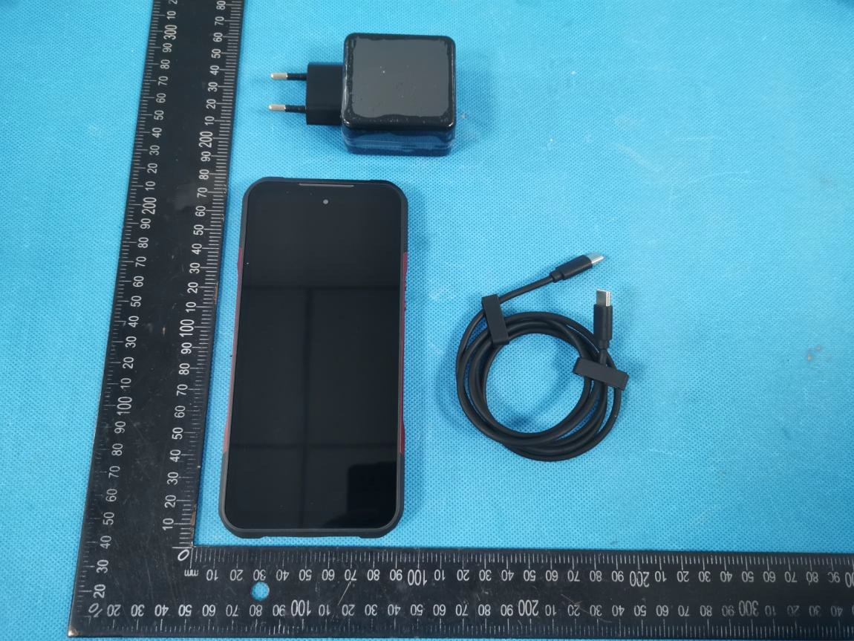

1. The object of the declaration described above is in conformity with the relevant Union harmonization legislation: Directive 2014/53/EU (RED)
2. References to the relevant harmonized standards used or references to the other technical specifications in relation to which conformity is declared:

|  |  |
| --- | --- |
| Referenced Standards: | |
| Article 3.2 Radio: | ETSI EN 301 511 V12.5.1 (2017-03);  ETSI EN 301 908-1 V15.1.1 (2021-09);  ETSI EN 301 908-2 V13.1.1 (2020-06);  ETSI EN 301 908-13 V13.2.1 (2022-02);  ETSI EN 300 328 V2.2.2 (2019-07);  ETSI EN 301 893 V2.1.1 (2017-05);  ETSI EN 300 440 V2.2.1 (2018-07);  ETSI EN 303 345-1 V1.1.1 (2019-06);  ETSI EN 303 345-3 V1.1.1 (2021-06);  ETSI EN 303 413 V1.2.1 (2021-04);  ETSI EN 303 417 V1.1.1 (2017-09) |
| Article 3.1 EMC: | ETSI EN 301 489-1 V2.2.3 (2019-11) |
| ETSI EN 301 489-3 V2.1.1 (2019-03) |
| ETSI EN 301 489-17 V3.2.4 (2020-09) |
| ETSI EN 301 489-19 V2.1.1 (2019-04) |
| ETSI EN 301 489-52 V1.2.1 (2021-11) |
| EN 55032:2015+A1:2020 |
| EN 55035:2017+A11:2020 |
| EN IEC 61000-3-2:2019+A1:2021 |
| EN 61000-3-3:2013+A2:2021 |
| Article 3.1a Safety: | EN 62368-1:2014+A11:2017 |
| Article 3.1a Health | EN 50360:2017; |
| EN 50566:2017; |
| EN 62209-1:2016; |
| EN 62209-2:2010; |
| EN 62479:2010; |

1. Notified Body Name: Eurofins Electrical and Electronic Testing NA, Inc.

Notified Body Number: 0980

Notified Body Assessment Performed: Module B/C on Article 3.1a, 3.1b, 3.2 and 3.3 Technical File Identification Number: N/A

EU-type examination certificate number:xxx

1. Where applicable, description of accessories and components, including software, which allow the radio equipment to operate as intended and covered by the EU declaration of conformity: User instructions are provided in the User Manual. The Software and Hardware versions are specified above.
2. Additional information:

Referring to Article 10.2 of the Directive, this equipment is so constructed that it can be operated in all Member States, without infringing applicable requirements on the use of radio spectrum.

Referring to Article 10.10 of the Directive, there are no restrictions on putting this equipment intoservice or of requirements for authorisation of use. Please refer to the User Manual for details.

On behalf of:

Manufacturer: Shenzhen DOOGEE Hengtong Technology CO.,LTD

Add: B, 2/F, Building A4, Silicon Valley Power Digital Industrial Park, No. 22, Dafu Industrial Zone, Guanlan Aobei Community, Guanlan Street, Longhua New District, Shenzhen, Guangdong China

(place and date of issue): 1/22/2024

(name, function): …………Li ZhiJuan………

(signature): …………… ……………………

